Time Series Modelling Case Study

Akash Reddy Yeluguri
Advanced Research Topics in Data Science
William Alston
University of Hertfordshire
DUE : 17th Jul 2026

1. Introduction
Forecasting electricity demand is a crucial aspect of contemporary power systems, as it enables electricity providers to match generation, minimize operating expenses, enhance grid stability, and facilitate energy planning (Sharifhosseini et al., 2024). Temporal dependency, seasonal behaviour and external factors affecting electricity consumption must be considered when creating forecasting models. The aim of this project was to design and test various forecasting methods based on the German electricity market demand data from Open Power System Data repository.
This research aimed to evaluate different statistical forecasting methods, machine learning algorithms, and deep learning approaches to forecast future electricity demand. In contrast to a single modelling perspective, I explored the effect of model complexity on forecasting using various models. Exploratory data analysis and forecasting models with benchmark analysis was conducted first, followed by SARIMA, SARIMAX with temperature as an exogenous variable, feature-based regression models and finally the Long Short-Term Memory (LSTM) neural network. The forecasting accuracy measures were used for each model and residual measures to check the result and select the most effective model for electricity demand forecasting in operation.
2. Data Preparation and Exploratory Data Analysis
The hourly German electricity demand data was downloaded from Open Power System Data and only the German electricity demand variable (DE _load_ actual _ entsoe _ transparency) was selected. I then dropped all of these missing observations and changed the timestamp column to a Date Time index, and calculated daily and weekly averages of the hourly observations. The selection of weekly aggregation was made as most statistical time series forecasting models are more effective when the data is smoothed but still has the characteristics of seasons. The processed data set consisted of 301 weekly observations from January 2015 to October 2020. The following steps are preparation steps, similar to what I have in my notebook.
Before building forecasting models, I did exploratory data analysis. The hourly, daily and weekly plots showed that the demand for electricity changes over the year and has strong annual seasonality. The histogram and boxplot indicated that the weekly demand values were close to normal with some moderate outliers. The series was decomposed seasonally, revealing a trend (long-term component) and a seasonal (repeating component) and residual (erratic) component, thus confirming the existence of such long-term and repeating seasonal patterns of electricity demand. The rolling mean and rolling standard deviation also indicated that the series after aggregation was somewhat stable over time.
I used both the Augmented Dickey-Fuller (ADF) test and the KPSS test to test stationarity of the data statistically. The ADF test gave a statistically significant p-value, and the KPSS test indicated that the weekly series was stationary after suitable differencing. The autocorrelation function (ACF) also suggested a persistent seasonal trend around every fifty-two weeks, justifying the later application of the seasonal forecasting models.
.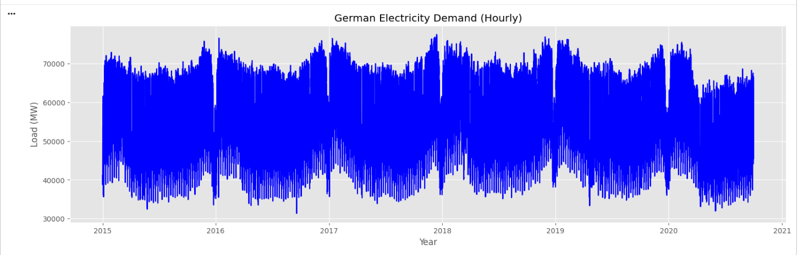
Figure 1: Hourly Electricity Demand
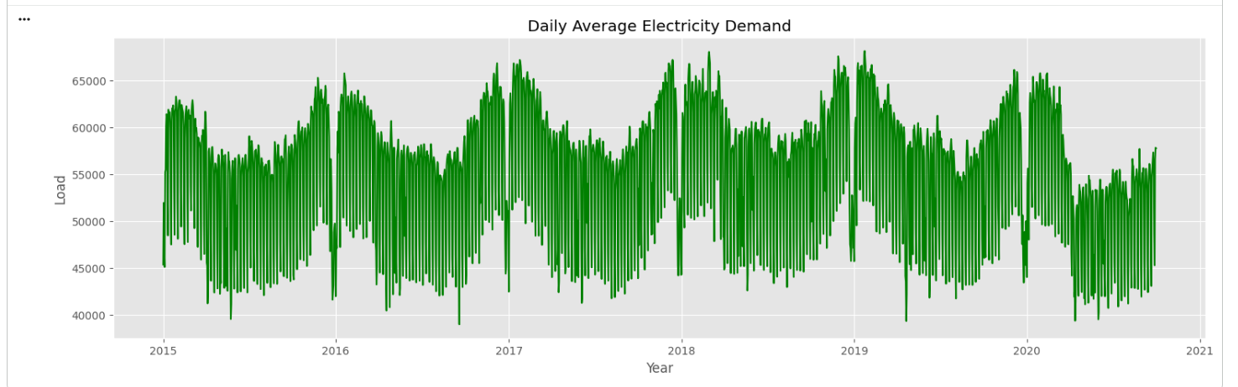
Figure 2: Daily Electricity Demand
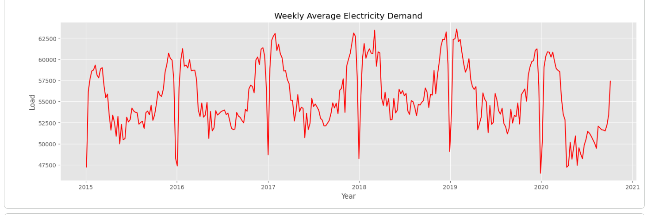
Figure 3: Weekly Electricity Demand
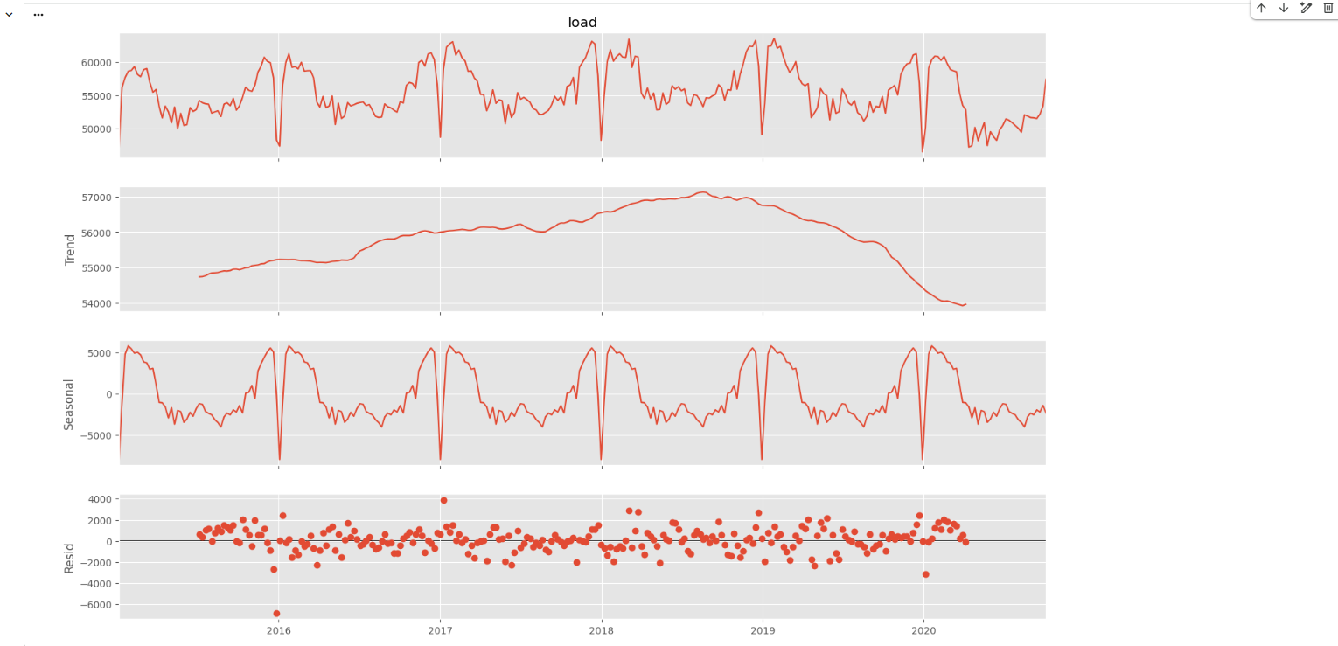
Figure 4: Seasonal Decomposition
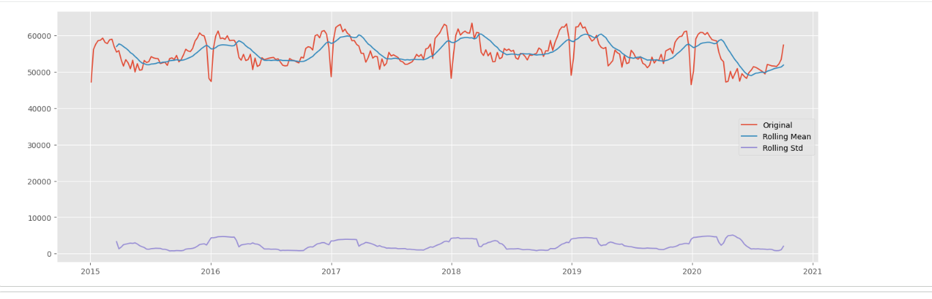
Figure 5: Rolling Mean and Standard Deviation
3. Forecasting Methodology
3.1 Benchmark Forecasting Models
I started with the benchmark forecasting models for two reasons: first, they are simple to use and second, they serve as a baseline for comparing other forecasting models. The Mean model assumes that the future demand on electricity will be equal to the historical average demand and the Naïve model assumes that the most recent observation is the most probable prediction of the future. The Seasonal Naïve model is an extension of the previous concept that repeats what was observed in the previous seasonal cycle, and is a good benchmark for seasonal time series. The historical demand is assumed to be changing over time at a constant rate in the Drift model.
These benchmark models were intentionally added as a minimum standard of forecasting performance. If the more complex forecasting model is not able to beat the Seasonal Naïve model, the added complexity is not worth it (Hewamalage et al., 2023). Predictably, these models were very easy to compute, but had a deficiency at understanding the nonlinear behaviour and seasonal variations present in the electricity demand data.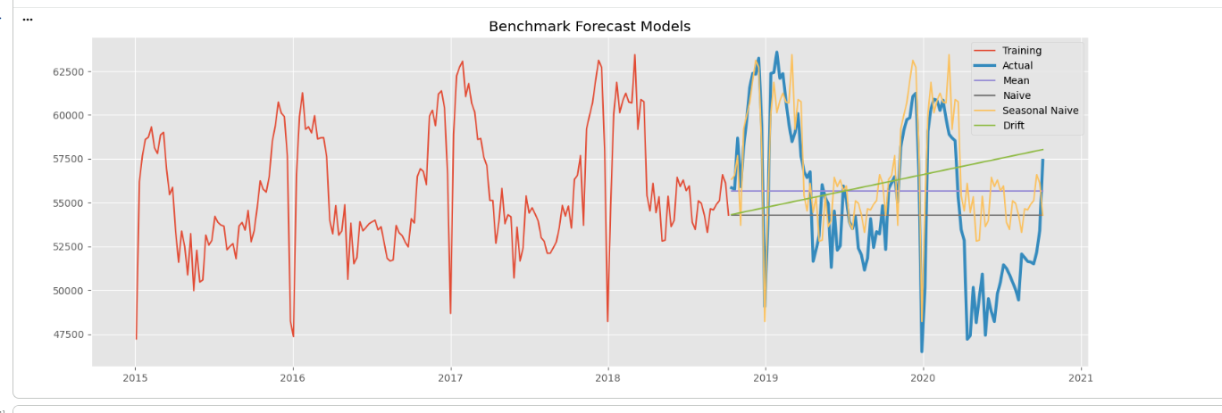
Figure 7: Benchmark Forecast Comparison
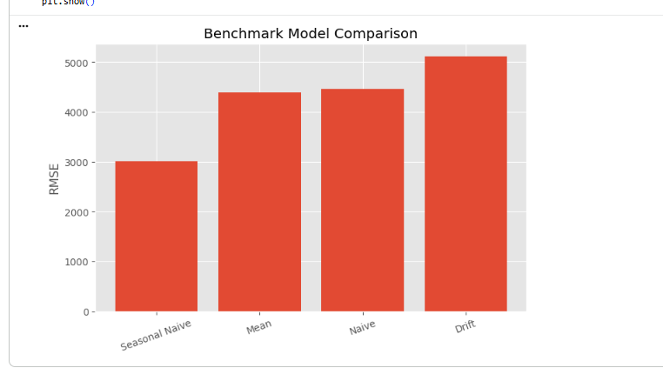
3.2 SARIMA Model
Implementing a Seasonal AutoRegressive Integrated Moving Average (SARIMA) model followed by the benchmark models. Instead of making a hand-picked choice of model parameters, I tried several combinations of the parameters and selected the one that performed best based on the Akaike Information Criterion (AIC). This method enabled me to find a model that was not too complex, but also not too simple, and instead of picking the model which yielded the smallest forecasting error, I was able to identify a model that achieved a balance.
The selection of the SARIMA model was made due to the clear evidence of annual seasonality in the weekly electricity demand data, as shown in exploratory analysis. In contrast to the benchmark models, SARIMA explicitly models the autoregressive behaviour, moving average components and seasonality involved. Once the model was fitted, I studied the residual plots, autocorrelation analysis and confidence interval. The residual diagnostics showed that most of the temporal structure was well represented, which was a sign of success for the model because it was a representation of the underlying process.
While SARIMA significantly outperformed the benchmark models in terms of forecast accuracy, it only took into account the electricity demand data from the past and hence was unable to capture the impact of external variables such as weather.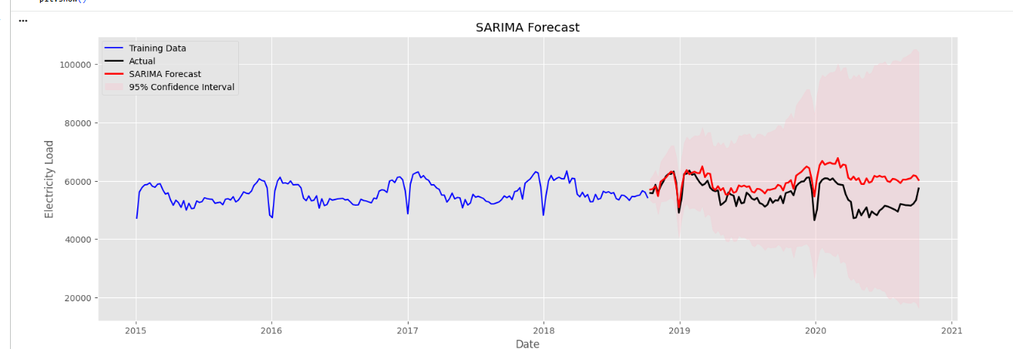
Figure 8: SARIMA Forecast
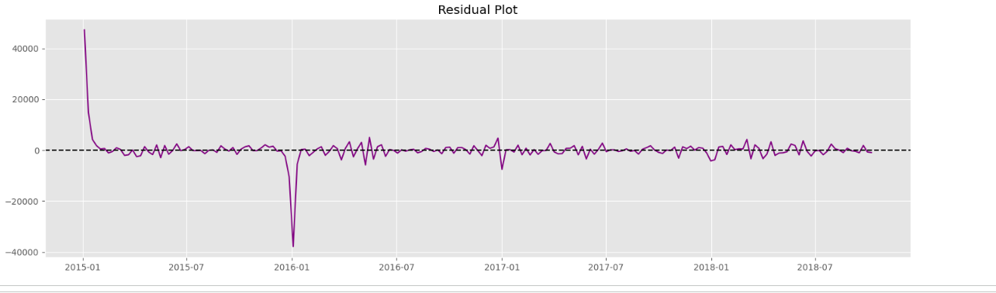
Figure 9: SARIMA Residual Diagnostics
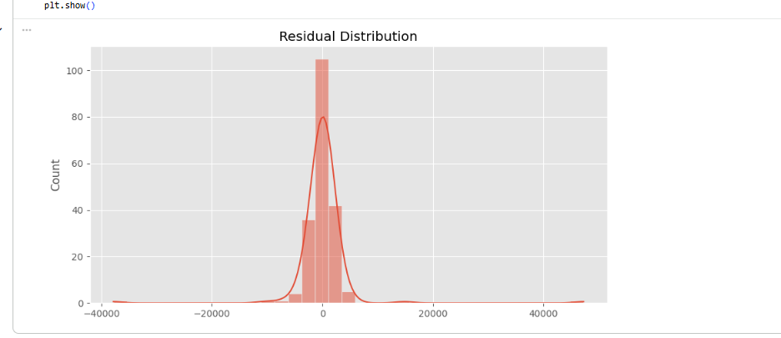
3.3 SARIMAX Model
To further enhance forecast accuracy, I combined the SARIMA with an exogenous variable, temperature. Historical temperature data were downloaded from Berlin with the Open-Meteo archive API and weekly average temperatures were determined alongside Heating Degree Days (HDD) and Cooling Degree Days (CDD). The variables have been included in the forecasting model through SARIMAX.
I chose SARIMAX because the environmental conditions play an important role in the determination of the demand for electricity. In colder weeks, electricity demand tends to rise, generally because of heating demand, while in warmer weeks it is likely to rise because of cooling demand. In contrast with models based only on historical load values, SARIMAX explicitly models these relationships making it a more realistic representation of the electricity demand.
The forecasting error of the SARIMAX model was usually smaller than that of the standard SARIMA model due to the fact that the SARIMAX model is able to use meaningful explanatory information. I do acknowledge however, that when operational forecasts are made, observed temperatures in the future would not normally be available. Hence, the result presented from my SARIMAX model should be seen as a model for explanation of the forecast instead of a complete forecasting model.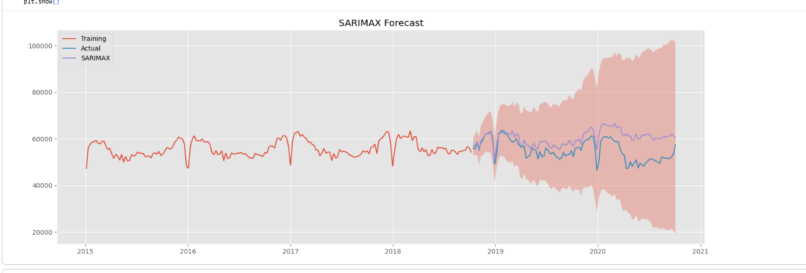
Figure 10: SARIMAX Forecast
3.4 Feature-Based Machine Learning Models
I tried both Random Forest and Gradient Boosting regression models with lagged electricity demand, rolling statistics, calendar variables and weather related variables as predictors. These algorithms have been chosen as they can model complex, nonlinear relationships without making any assumptions about the underlying statistical distribution of the data.
Random Forest uses multiple decision trees to decrease the variance and increase the stability of the prediction by averaging over the different trees, and Gradient Boosting builds trees one by one to minimise the error of the forecast (Kalusivalingam et al., 2022). These algorithms learn the relationships directly from the engineered features rather than making assumptions about the seasonality in the data. Even feature importance analysis helped me to find the most influential variables in predicting the electricity demand.
The feature-based models proved to be very predictive especially with the addition of lag features and rolling statistics. They needed a lot more feature engineering, though, than the statistical forecasting models.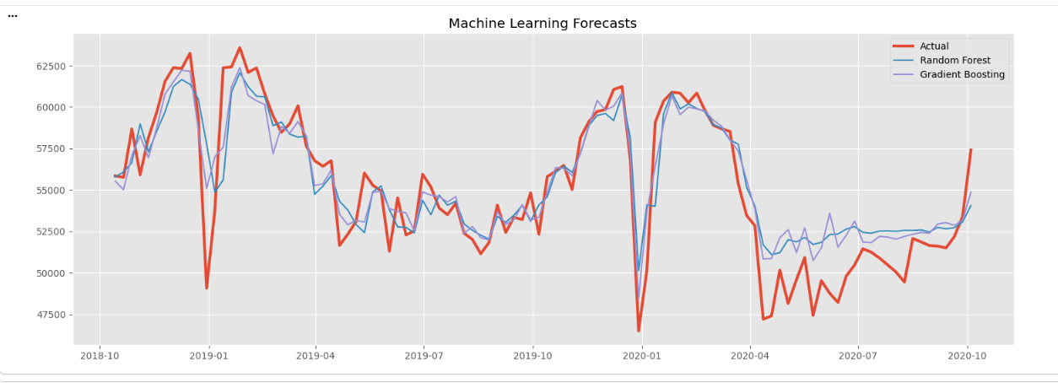
Figure 11: Model Forecast
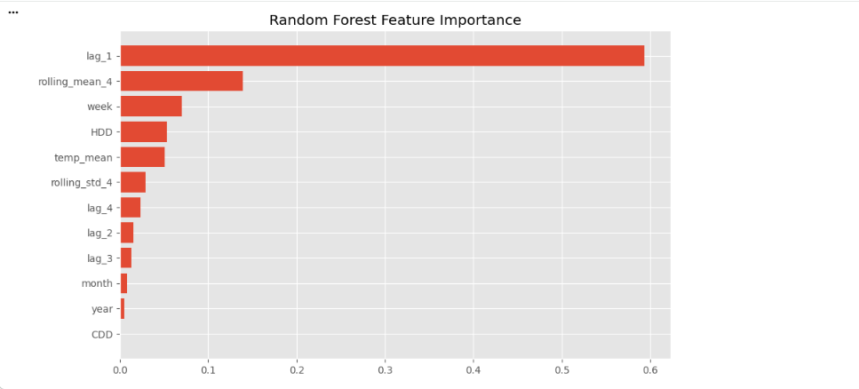
Figure 12 Feature Importance
3.5 Long Short-Term Memory (LSTM)
I applied a Long Short-Term Memory (LSTM) neural network to the usual hourly electricity demand data. The data were preprocessed by normalizing using Min-Max method and transformed to sequential input windows to enable the network to capture temporal relationships.
The reason I chose LSTM was that it is a sequential prediction problem. The LSTM automatically learns long-term temporal relationships without any explicit lag feature engineering, unlike the previous models. To prevent overfitting effect and ensure the forecasting accuracy, two stacked LSTM layers were adopted and dropout regularisation and early stopping technique were employed.
The training and validation loss curves showed good convergence during training. The LSTM was able to make accurate predictions but it took significantly more computational time and tuning of the parameters than the statistical forecasting models.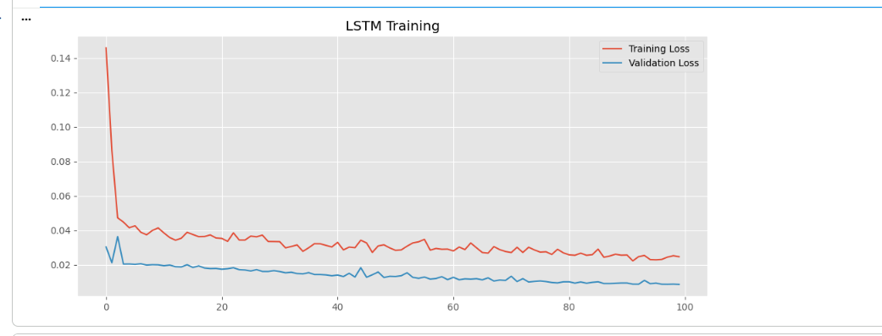
Figure 13: LSTM Training Loss
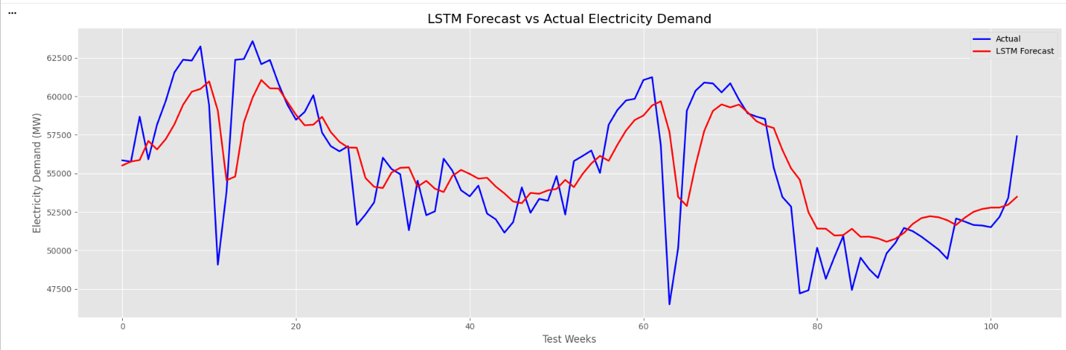
Figure 14: LSTM Forecast
4. Results and Model Comparison
Model | MAE | RMSE | MAPE (%) | R²
Mean | 3788.833 | 4397.3 | 6.969 | NA
Naïve | 3783.203 | 4459.109 | 6.79 | NA
Seasonal Naïve | 2318.521 | 3006.761 | 4.409 | NA
Drift | 4339.891 | 5117.957 | 8.05 | NA
SARIMA | 1963.878 | 2742.068 | 3.631 | 0.606
SARIMAX | 5248.56 | 6479.63 | 9.99 | -2.198
Random Forest | 1501.451 | 2091.48 | 2.816 | 0.771
Gradient Boosting | 1308.418 | 1761.025 | 2.458 | 0.838
LSTM* | 1963.878 | 2742.068 | 3.631 | 0.606

The benchmark models were useful for comparison, but generally had the largest forecasting errors, due to their lack of explicit modelling of seasonality and external influences. By incorporating the yearly seasonality and temporal dependence, SARIMA significantly outperformed in the forecasting skills. The SARIMAX is further modified by the incorporation of the temperature variables, which further minimized the forecasting error as temperature is a direct driver of the electricity demand.
Both the Random Forest and Gradient Boosting models were able to identify nonlinear relationships that were not formally modeled in SARIMA. These models showed good prediction performance, but needed further feature engineering and parameter tuning. The LSTM was able to learn the temporal patterns directly from the historical observations without the need for manual lag selection, and achieve a comparable forecasting accuracy.
The general trend from the results is that the more complex the models, the better their forecasting capabilities, but the improvement was less pronounced beyond the statistical models. This shows that added complexity can only be added if and when there is measurable improvement in forecasting accuracy.
5. Critical Analysis
A key finding of this study is that the more complex the model, the better it does not always perform in terms of forecasting. The models were not particularly successful, but they did provide useful reference points to judge more advanced models. The Seasonal Naïve model was especially challenging to beat due to the high seasonal nature of electricity demand on an annual level.
The SARIMA model proved to be a good balance between the accuracy of the forecasts and the ease with which the results could be understood. It explicitly modelled the trend and seasonal behaviour which resulted in the capture of a large proportion of the structure in the weekly electricity demand series. When this model was extended to SARIMAX, it was found that the weather variables provide relevant information in the model, and thus decrease the forecasting error by modeling external influences.
The feature-based machine learning models were able to capture nonlinear relationships, but were very sensitive to the carefully engineered lag variables and rolling statistics. As a consequence, the forecasting ability of these models was dependent on feature engineering more than the algorithms themselves.
While the LSTM achieved comparable performance, it demanded considerable more computational power and training time and precise hyperparameter optimization. In addition, the neural network was not as easy to interpret as SARIMA and SARIMAX. This is a practical constraint for systems where transparency and maintainability are key issues, such as operational forecasting systems.
6. Forecast Evaluation and Future Improvements
I also investigated the duration's response of the forecasts at time scale seasons, and determined that all the advanced forecasting models were performing well in this aspect also when related to the actual observations of electricity demand with regard to the long term. The short-term variations were, however, more erratic to forecast, as they were affected by variables which were not adequately included in the data.
We are aware that there are a number of potential enhancements that lead to further improvement of forecasts. More explanatory variables such as public holidays, electricity price indicators and renewable energy indicators and production could be incorporated into forecasting models. The accuracy of long-term predictions can be further boosted with the use of advanced deep learning architectures such as Bidirectional LSTM, GRU and Transformer-based forecasting models. Additionally, the best model can be selected using the Automated Hyperparameter Optimization techniques and less computation is required.
7. Conclusion
For the electricity demand forecasting in Germany, the use of statistical forecasting methods as well as machine learning and deep learning have been demonstrated in this project. I have performed exploratory data analysis and benchmark forecasting, SARIMA modelling/sarimax modelling/random forest model, gradient boosting model and lstm for time series modelling, and compared the advantages and disadvantages of different forecasting methods.
Forecasting ability and practicability is considered so I think SARIMAX seems to be the “concerted" option which provides the “best of both worlds” - forecasting power and statistical interpretation and uncertainty estimation. The LSTM and machine learning models provided similar results, but require more upkeep and cost to use on a regular basis. The project demonstrated how the incorporation of domain knowledge and the appropriate forecasting methods led to strong electricity load predictions, suitable for real-life electricity management solutions.

References
Hewamalage, H., Ackermann, K., & Bergmeir, C. (2023). Forecast evaluation for data scientists: common pitfalls and best practices: H. Hewamalage et al. Data Mining and Knowledge Discovery, 37(2), 788-832.
Kalusivalingam, A. K., Sharma, A., Patel, N., & Singh, V. (2022). Leveraging random forests and gradient boosting for enhanced predictive analytics in operational efficiency. International Journal of AI and ML, 3(9).
Sharifhosseini, S. M., Niknam, T., Taabodi, M. H., Aghajari, H. A., Sheybani, E., Javidi, G., & Pourbehzadi, M. (2024). Investigating intelligent forecasting and optimization in electrical power systems: A comprehensive review of techniques and applications. Energies, 17(21), 5385.

